**VTA**

**jgfhhff**

(Virtual Technical Assistance)

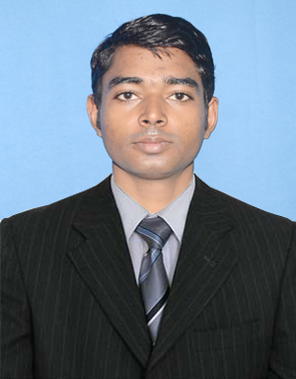

**Name – Deep Govind (Software Enginear)**

[**Email—deepgovind4@gmail.com**](mailto:Email—deepgovind4@gmail.com)

**Mobile No : 7388966141**

**INDEX**

1. INTRODUCTION TO VTA
2. VTA FEATURES
3. ABOUT VTA FOR PROGRAMMER
   1. PROGGRAMMMING LANGUAGE
   2. USED LIBRARY
   3. USED COMPILER FOR PROGRAMMING
   4. PROGRAM DETAILS
   5. WORKING FLOW CHART
4. REQUIRNMENT FOR INSTALLINGG VTA
5. INSTALLING VTA
6. ADD COMMAND
   1. ADD ONE KEYBOARD COMMAND
   2. ADD ONE MOUSE COMMAND
   3. ADD ONE CMD COMMAND
7. SET VTA PROPERTY
8. START ENGLISH TYPING
9. START HINDI TYPING
10. START ENGLISH TO HINDI DICTIONARY
11. START CHAT

**INTRODUCTION TO VTA**

Vta is a voice recognize. Vta provide a interface bitween your voice and computer command . you can control your computer using your voice and it is a virtual assistance , you can ask qustion and get batter answer so it is called virtual technical assistancs. This software created in **JAVA, C, C++, AIML, CSS** embaded language . you can control your compure **CMD , KeyBoard** , **Mouse** command with your voice. For **cmd** you can say open c drive this software send command to cmd ( C:> explorer c:\ ) autometic , you can add more then one command which works in CMD For **KeyBoard** if you say copy Vta send Clrt+C Keyboard command and if you say past then Vta send Clrt+V key command you can add more command in Vta. For **Mouse** need to capture image where mouse will click, image capture process is inbule in Vta this process is following. for example if you capture minimize image if you say minimize Vta search this picture in active window if found then Vta move mouse found location and send click or double click command.

Vta provide English and hindi voice typing if you start hindi typing you can speak in hindi all speaking word autometic write. Vta also provide a english word to hindi word convertor, when in hindi typing process some words write wrog you can type english word of hindi in dictionary enhlosh word autometic will convert in hindi.

Vta is a good virtual assistance you can ask qustion and get answer.

**VTA FEATURES**

1. Control your computer with voice.

2. control windows CMD command with voice,

3. control Mouse double and single click by giving refrencf of image to click.

4. control key board command , send key by voice .

5. provide voice hindi typer.

6. provide voice english typer.

7. provide englich to hindi convert.

8. Your Virtual Assistance, you can ask qustions and get answer.

**PROGGRAMMMING LANGUAGE**

Vta is created in embaded programming language , language is :-

C, C++, java programming languaage and AIML marcup language and CSS for desigen interface style . JSGF V1.0 use for creat voice recognize grammer.

1. C ~= 20%
2. C++ ~= 50%
3. Java ~= 20%
4. AIML ~= 7%
5. CSS ~= 1%
6. JSGF V1.0 ~= 2%

**C** language use for send mouse, keyboard command and get active window. C is also use for image process in opencv.

**C++** langguage use for Design User interface, control process and work with interface.

**Java** is use for voice recognize recognize and speak typing.

**AIML** use for Artificial intelligent ( Qustion Answer ).

**CSS**  is use for change style in UI.

**JSGF V1.0** is use for creating Voice Recognize and Voice command grammer to spinx4.

**USED LIBRARY**

Vta use many difference library combinetion . Library are :-

1. Sphinx4 java library for voice recognization .
2. C & C++ system library.
3. OpenCV 3.0 for image process and object recognization which is writen in c & c++ language.
4. Qt 5.6 is use for UI desigining and working process.
5. AIML use for Artificial intelligent.
6. . freetts for text to speak.

**USED COMPILER FOR PROGRAMMING**

1. To compile C & C++ program used GNU mingw32 5.3.0v
2. To compile java program use jdk 8.45

**PROGRAM DETAILS**

1. **VirtualTecnicalAssistance.exe** is Vta program. (Start Manualy)
2. **VtaKeyBoard.exe** is English word to hindi word converter. (Start Manualy)
3. **VtaSR.exe**  is command recognize program.
4. **tts.exe**  is use for text to speech . (Start Manualy)
5. **VtaTyperEnHi.exe** is use for english to hindi typing (Start Manualy)

You can pass VtaTyperEnHi.exe in cmd and as argument En Or Hi

(VtaTyperEnHi.exe En or VtaTyperEnHi.exe Hi)

**WORKING FLOW CHART**

Stop

Speak hindi typing start ( as you set to speak for hindi typing )

Speak english typing start ( as you set to speak for english typing )

Speak Command

Vta Load AIML Library and check Voice command enable or dicable for AIML

Vta Start VtaKeyBoard.exe

Vta start VtaTyperEnHi.exe with command En

Vta start VtaTyperEnHi.exe with command Hi

Speak dictionary start ( as you set in setting in to start dictionary )

Vta start a process VtaSR.exe which recognize Voice command

Start Vta

**REQUIRNMENT FOR INSTALLING VTA**

**Vta installing Requirnment:-**

1. Jre or jdk ( for speak recognization )
2. Windows 32-bit or 64-bit
3. 500 GB or More Ram
4. A good process.

**INSTALLING VTA**

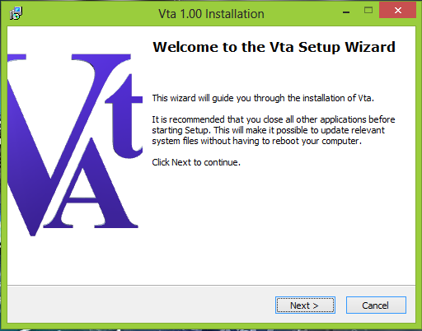

Click Next :-

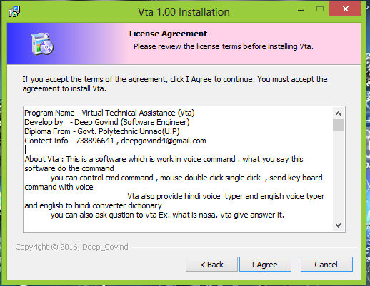

Click I Agree > Nexe > install >Finish.

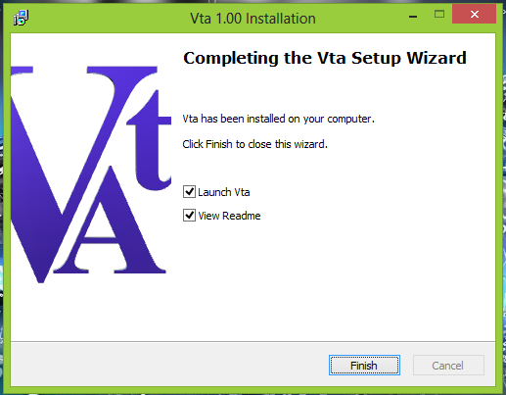

**ADD COMMAND**

**ADD ONE KEYBOARD COMMAND :-**

Add Close Window Command :- ( Alt+F4)

1.Write Voice Text : close window // this is voice recognize text

2.Select Type : SendKey // following command send to KeyBoard

3.There are show two text box show select key command from combo boxs.

Clear : Write Arguments Text;

1. Select : VK_ALT{0x12}

2. Select :VK_F4{0x76}

After selecting key in following text box type a command : VK_ALT{0x12}+VK_F4{0x76}

( This Command Will be send ).

4.Write Arguments :VK_ALT{0x12}+VK_F4{0x76} // you can pass argument also

5. click add button.

6. your command save for next start or start your application again.

In following command : if you speak close window then Vta send KeyBoad command

alt+f4.

**Note**: if you went to send more then one key command Write Arguments using key box

VK_ALT{0x12}+VK_F4{0x76};VK_ALT+;VK_LCONT{0x23}+V;.......

VK_ALT+ for single key command.

VK_LCONT{0x23}+V for double key command;

all command sepreted by ';' .

Picture :

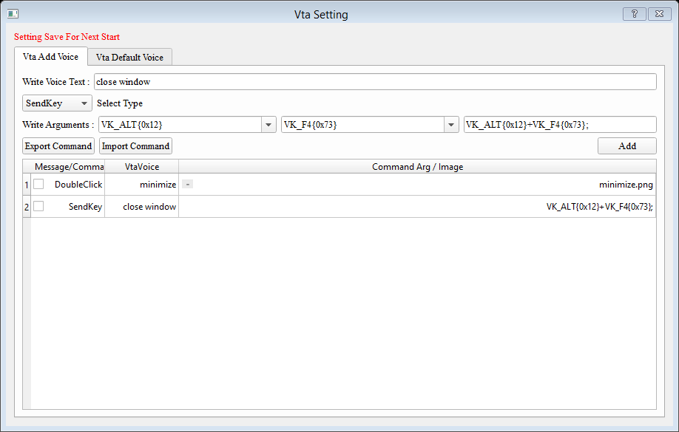

**ADD ONE MOUSE COMMAND:-**

**DoubleClick :**

1.Write Voice Text : minimize // this is voice recognize text

2.Select Type : DoubleClick

3.Write Arguments : minimize // name of image

4.click Capture Image button

5.move Image Capture Box to Minimize image and press enter key.

**Note** : when you speak minimize Vta send Mouse double click command in active window .

**SingleClick :**

Send Single click mouse command in captured image.

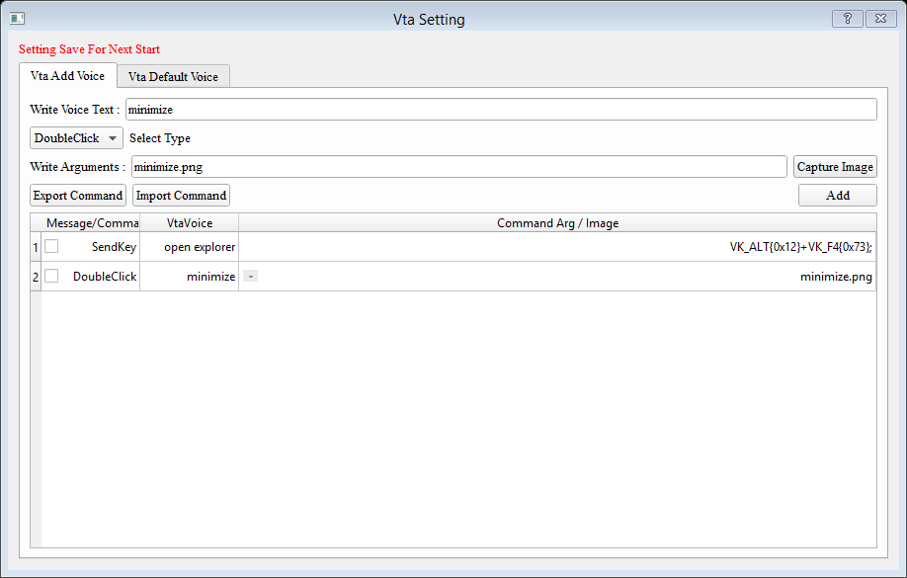

**ADD ONE CMD COMMAND :-**

2.Select Type : ToCMD // following command send to cmd

3.Write Arguments :explorer //or explorer C:\ or notepad.exe // you can pass argument also

5. click add button.

6. your command save for next start or start your application again.

In following command : if you speak open explorer Vta send command to CMD

( As you work in windows cmd ) explorer .

Picture :

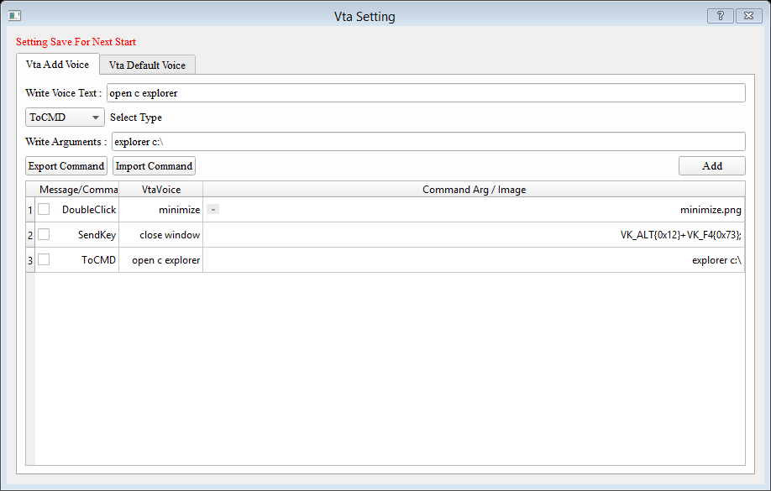

**SET VTA PROPERTY**

1. Set Hindi Typing Txt : Set The Word which you speak then hindi typing Software Start .
2. Set English Typing Txt : Set The Word which you speak then English typing Software Start
3. Set Dictionary Start txt : Set the word which you speak then english to hindi convertor start.
4. Time to sleep :Set second to sleep Vta . After tis second Vta go to sleep or Vta Command not work
5. Get Up txt : set the text which you then Vta get up from sleep and all command work .
6. Sleep Text : this is sleep Vta Text . when you say this word Vta go to sleep immidently.
7. Auto Start Checkbox : set checked then Vta start autometic when computer on.
8. Off Recognize CheckBox : If this checkbox is checked then Hindi , English ,dictionary start command not Recognize.

**START TYPING**

If Hindi typing Started Then Open a Notepad , Word…….. and Start Speak.

**START DICTIONARY**

When Dictionary is start , Type english word in Textbox hindi convirtion show auto select hindi word and press enter.

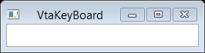

**START CHAT**

Write Qustion in Vta Text Box and press enter.